Add Schedule Type, Crosslisting or Campus to Courses

- Go to https://nextcatalog.oregonstate.edu/courseadmin/

- Log on using your ONID username and standard password. DUO is required.

- In the field to the left of the Search button, enter the subject code and number (e.g., MRKT 497 with a space in between) of the course proposal you wish to edit and press the green Search button.
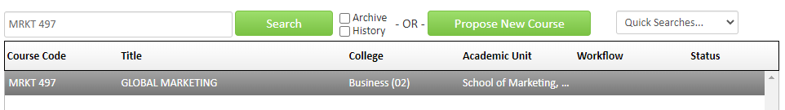
- Click on the green Edit Course button to open the form.

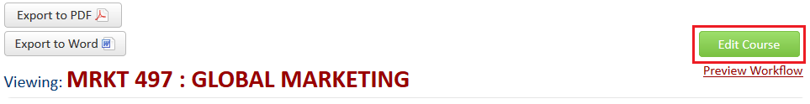

- CIM forms are dynamic so fields open and close based on selections you make early in the form. To ensure your request is expedited, it is essential that you select ‘Change Schedule Type, Crosslisting or Campus’ as the type of change. The form will shrink and only show fields that you are eligible to change.

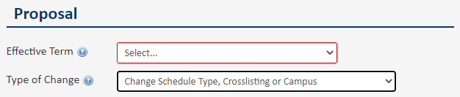

- Complete all required fields (outlined in red) before submitting your proposal. Some fields will pre-populate; however, since CIM is a new system, you will need to make additional selections.
Refer to the blue help bubbles in the CIM form or the Appendix on the next page if you are unsure what each field is referring to.

Questions? Contact cim.help@oregonstate.edu

APPENDIX

Effective Term: Select the term when you would like the change to apply – this can be different from the term in which you want to teach the course in that format. For example, for a crosslist request, if the effective term is Summer 2023, the course will appear in the Catalog as crosslisted from Summer 2023 even though you may not schedule the class until Spring 2024.

Justification: In a short sentence, explain what you are requesting. For example, ‘Adding XX schedule type.’

Primary Originators: Select your name from the drop-down list. You may add other people if you wish, but only the person submitting the proposal will receive the approval notification.

Type of Course: Most courses are ‘regular’ – do not select another course type unless you are sure what it is. Blanket, experimental and special topics courses have unique numbering.

Honors: Do not edit this field – honors courses cannot be added through this process.

Crosslist: Most crosslisted courses have the same number but a different subject code. Once the crosslist is established, the courses are linked through CIM and cannot be edited separately. Course level, title, credits, and description must be the same in crosslisted courses. Use the red Add link next the crosslist label and then enter the details into the course code widget.

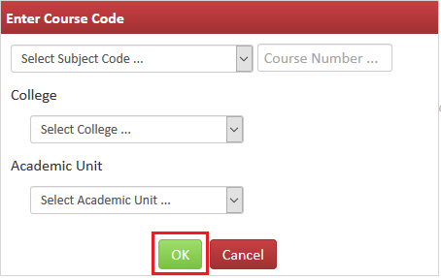
Note:
Once you click OK, you have the option to add another crosslist course. Or, the course you just entered can be edited, removed, or made the primary course.
Since crosslisted courses are linked together in CIM, one of them must always be the parent even though in Banner, they will have the same status.

Slashlist: Do not edit this field – slash courses cannot be added through this process.

Schedule Type: Schedule types already in Banner at the course level will pre-populate the form. If you wish to add a new schedule type, check the relevant box. Laboratory and recitation are exceptions and cannot be added through this expedited process. Requests to add laboratory or recitation require a full proposal, as does studio in certain situations. Contact cim.help@oregonstate.edu if you have questions.

Campus Locations: Make your best attempt to select all locations where this course is (or will be) offered.

Anticipated Scheduling: Make your best attempt to select all the terms where this course is (or will be) taught for all campuses – you can change scheduling later if you wish . You do not need to submit another proposal change scheduling.

