EDIT AN EXISTING COURSE

- Go to https://nextcatalog.oregonstate.edu/courseadmin/

- Log on using your ONID username and your standard password. DUO is required.

- In the field to the left of the Search button, enter the subject code and number (e.g., WR 573 with a space in between) of the course proposal you wish to edit and press the green Search button.
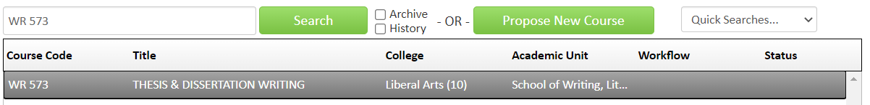

- Click on the green Edit Course button to open the form.
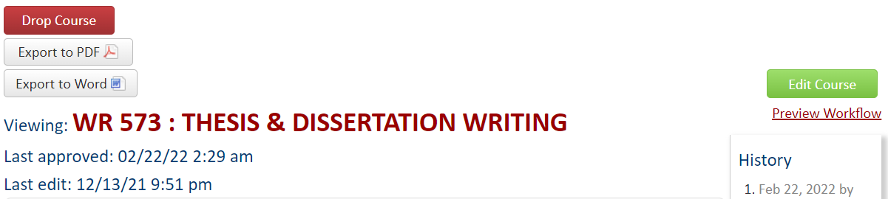

- CIM forms are dynamic, so fields open and close based on selections you make early in the form. To save you time and effort, it is essential that you select the correct “Type of Change”.

- Complete all required fields (outlined in red) before submitting your proposal. The required fields are determined by the type of course. Refer to the blue help bubbles if you are unsure what each field is referring to.

- If the course change warrants a full curricular review, a syllabus must be attached. To upload your syllabus, click the green Attach File button at the bottom of the form.
- To save the information you have entered, without submitting the proposal, scroll to the bottom of the form and press the Save Changes button. You can do this as often as you like.

- Once your proposal is complete, press the green Submit button to enter it into workflow (start the review process).

Tips:
- Refer to How to Write a Good Proposal to ensure a smooth approval of the proposal.
- Ensure that the course syllabus meets the Syllabus Minimum Requirement.

Questions? Contact cim.help@oregonstate.edu

Questions? Contact cim.help@oregonstate.edu

Changes to regular courses generally warrant a full curricular review, except for changes outlined in the Expedited Category II policy. Changes to blanket, experimental, and special topics courses are expedited.

