Contents
Overview 1
Build a Course List (Program Requirements) 2
Propose New From Existing 2
Course List 2
Quick Add 3
Text Entry 3
List of Requirements 4
Red Box Errors 5
Fields and Features 6
Total Hours 9
Page Body Text 9
Linking Courses to Banner 10
Create a Footnote 11
Build a Sample Curriculum Plan 13
Frequently Asked Questions 15
Catalog Content Not Showing in CIM 15
Standardized Language and Formatting 16
Total Hours are Incorrect 16

Overview

Program requirements must be built using the pre-formatted CIM ‘Course List’ widget because:
- They are Screen Reader-accessible and mobile-friendly
- They ensure consistency of language and format across all programs, colleges and units
- They feed directly into the Catalog so there is less chance of data entry errors
- They are populated by data from our SIS, Banner, so you have access to accurate and immediate course information
- They populate to the ecosystem of the course form which allows proposal originators and reviewers to see every program that uses a specific course, providing a holistic view of the curricular landscape and assisting with liaison selection

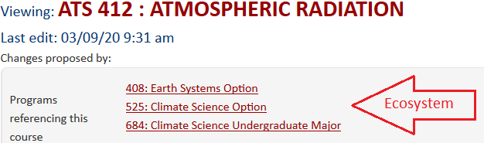

CourseLeaf provides additional resources and videos through their help site. To access:
- Click on the help bubble in the corner of the CIM landing screen
- Type ‘Course List,’ ‘Footnote’ or ‘Study Grid’ into the search field
- Click on either of the top two results

Build a Course List (Program Requirements)

Propose New From Existing

- If you are proposing a new program and would like to pre-populate your proposal with information from an existing program, use the ‘Propose New from Existing Program’ at the top of the new program proposal form. ‘Proposing new from existing’ creates a template for your new program which you can then edit as needed.

- If you have already completed or are part-way through your proposal but you would like to use the requirements of another program as a template, contact cim.help@oregonstate.edu and they will assist in copying an existing course list into the proposal for you.
- Once populated, double-click on the course list table outlined in blue and then follow the instructions from step 4 onwards.

Course List

- To build your course list from scratch, select the table icon in the toolbar

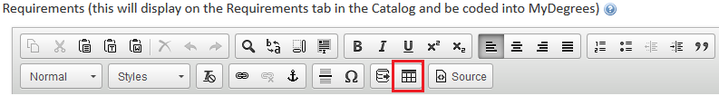

- Select ‘Course List’ from the drop-down field (it should appear first and be the default) then click ok

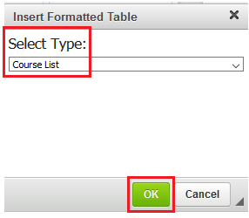

- When the course list widget opens, select your college (division) and associated subject code (subject)

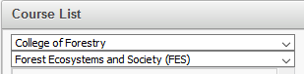

Quick Add

  - Selecting college and subject code provides a shortcut to your courses but you can also use the Quick Add box to add courses

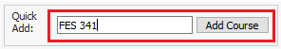

- Build your requirements by double-clicking on courses in the box on the left-hand side or by manually typing them into the Quick Add box and pressing ‘Add Course’
  - As you add courses, your list will build in the box on the right-hand side

Text Entry

- Use Add Comment Entry for anything that is not a specific course
  - Most often this will be text such as ‘Required Core,’ ‘Electives,’ ‘Bacc Core,’ ‘Select one course from the following:’

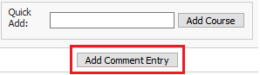

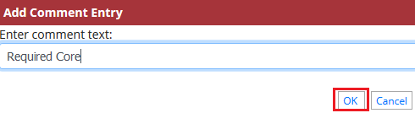

- If you are using a course from another institution in your requirements and would like it to format the same as an OSU course, add two colons (::) between the course number and title in the Add Comment Entry and manually enter the credits (more information on credit field below)

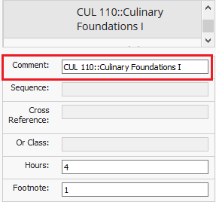

  - The course is not linked to Banner so you will likely need to add a footnote or parentheses clarifying why or where the course may be taken. Eg, 1 – Taught at Central Oregon Community College (COCC)
  - This can also be useful for OSU courses where a subject code is specified but any course number will be accepted. Eg, PAC XXX::Physical Activity Course or WSE 50X::Wood Science & Engineering Blanket Course

List of Requirements

- You can make changes to your list using the arrows in the middle. Right-to-left removes courses/text and left-to-right adds courses (only)
  - You must highlight the course or text before clicking on an arrow
  - Do not worry if you remove a course that is not the same subject code as the list on the left-hand side – CIM will not retain it under the wrong subject code once the widget is closed
  - If you remove text by accident, you will have to type it in again using Add Comment Entry – unlike specific courses, the widget does not remember text that you have removed from the requirements

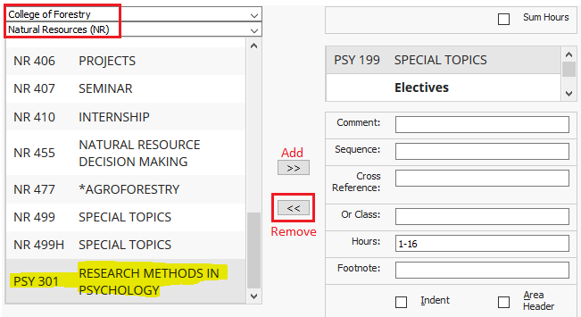

Red Box Errors

If a valid course displays with a red box around the credits, there is a discrepancy with the credits you have entered in CIM and the credits for the course in Banner.
- The easiest fix for this is to manually type the correct credits into the credit field
- If the credits are not wrong, you can leave the red box as it is – the red box is a warning; it does not stop processing or approval of your proposal. See ‘Hours’ under Fields and Features below for more information

If you add a course that is not valid in Banner or CIM, a red box will appear around the course alerting you to that. You can either delete the course in the course list or add a comment indicating that a proposal is pending approval.

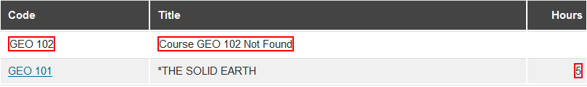

Fields and Features

- Once added to the requirements box (right-hand side), you can format your list in a variety of ways using the fields underneath

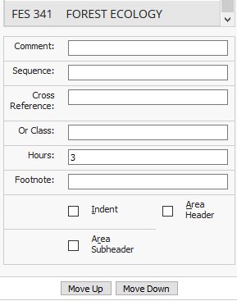

Comment – Displays in parentheses after the course title
- Parentheses will appear automatically – you don’t have to type them in
- Do not add a comment indicating that a course is taught online – Ecampus availability will automatically display in the course description

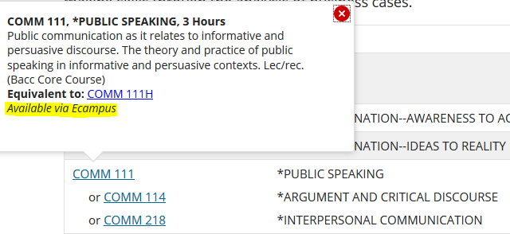

Sequence – Displays two courses with an ampersand (&)
- Most often used to indicate a series of courses (eg. FR 111, 112, 113) or two courses that should be taken together (eg. CH 232 and CH 262 Laboratory for CH 232)
- Any comment will display after the final course in the sequence

Cross Reference – Courses with a crosslist, slashlist or honors relationship
- Will appear with a slash between them in the course list

Hours – Credit hours as currently approved in Banner
- If the field is blank, a proposal may be in progress which changes the credits
- Change credits as needed, especially if:
  - You only allow a maximum amount of credits to be earned from a blanket or special topics course with variable credit
  - You are using a sequence of courses and the sum of the two courses must be added together – if the hours are not manually changed, the course list will show a red box around the value indicating that there is a discrepancy
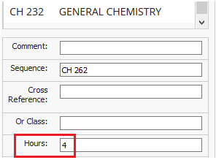

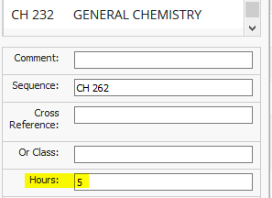

Or Class - Displays two courses with the word "or" indicating that either course may be taken to meet the requirement

Footnote – Add the footnote symbol but not the full text of the footnote
- Add text using a ‘Footnote’ table once the ‘Course List’ is displaying in the page body
- Further instructions can be found at the end of this guide
- Be careful when using numbers as footnotes – they will not automatically update if you place one out of order

Indent – Prevents credits for a specific course from displaying or being added to the total
- Most often used in elective lists where the credits are added to a comment such as “Select XX courses from the following:”

Area Header – Text added using Add Comment Entry will be styled as a header within the table
- Most often used to indicate ‘Required Core’ or ‘Electives’

Area Subheader – Text added using Add Comment Entry will be bolded and italicized but not appear as the largest header
- Most often used to indicate areas of emphasis or tracks and used in conjunction with indented courses

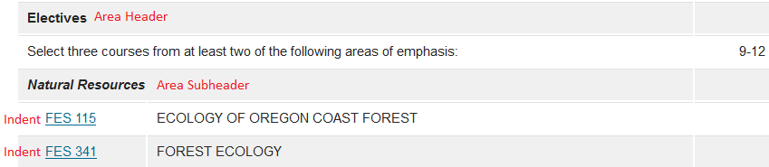

Total Hours

- Once your course list is complete, click on ‘Sum Hours’ in the top right-hand corner so that your credits sum together
  - In some cases, particularly for undergraduate majors where course requirements are extensive and convoluted, this checkbox can be left unselected
  - Minors, options and certificates where credits are usually less than 50 should always have the ‘Sum Hours’ box checked – this ensures accurate coding in MyDegrees, verification of meeting the university’s policy on Minimum Credit Requirements and a transparent program of study for students

- Click ok once you have finished adding your requirements or to check your progress
  - Be careful – if you select cancel, your changes will not save

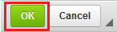

Page Body Text

- You can add text outside of the blue course list area but for ease of reading, especially for students using a Screen Reader, utilize course lists and footnotes where possible
  - If you must add text to the page body, numbered or bulleted lists should be used in lieu of full sentences. For example, instead of “A minimum GPA of 2.0 is required and no courses for the minor may be taken S/U,” add a bulleted list:

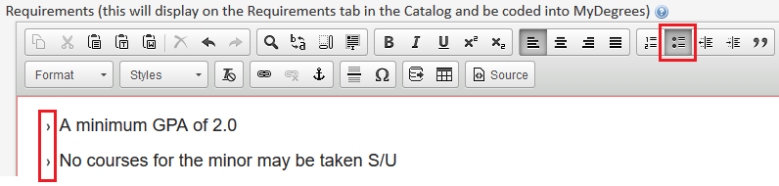

  - If you cannot place your curser where you want your text, hover your curser underneath the previous field and click the red arrow to create a new paragraph

  - You can add multiple course lists by using the red arrow to create a new paragraph and then clicking on the table icon
    - Multiple course lists are most commonly used for majors where an overview/summary table precedes the separate requirements course list or to differentiate degrees – they should not be used to separate core requirements from Bacc core requirements
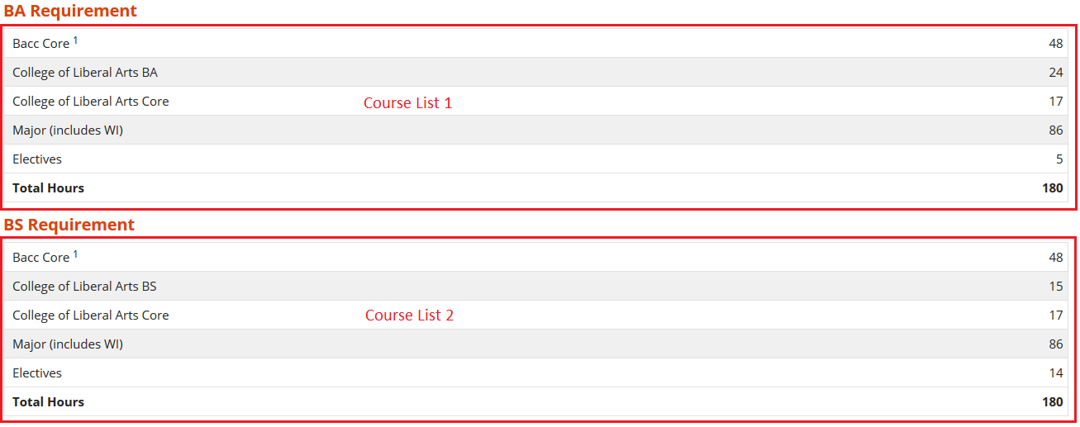

Linking Courses to Banner

- If you want to list courses in the page body or a footnote, they can display in the same dynamic way as your course lists with a pop-up box showing course description and credits
  - Highlight the course you wish to link
  - Double-click on the database field icon in the toolbar
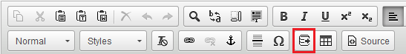

  - If the course is active in Banner, a blue box will appear around the course indicating that it is now linked
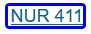
  - If the course is not active in Banner, a red box will appear around the course indicating that there is no Banner data to link to
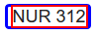
  - If you do not know the course or have forgotten the number, double-click on the red box and select the correct number from the list or open the database icon without selecting a course
  - Select the college (division) and subject code (subject) from the top drop-down fields and double click on the course you want to insert
  - Alternatively type the course into the Quick Add box and press ‘Add Course’
    - You can choose in which format your course appears but OSU standard practice is subject code and course number only – this reduces the word count and ensures consistency across campus.
    - Title and credits will still display in the course description pop-up box

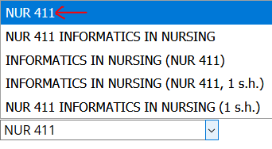

  - Click ok and your course will display in the page body with a blue box indicating it is now linked to Banner

Create a Footnote

- Indicate a footnote symbol in the footnote field of the course list widget
  - Be careful when using numbers instead of symbols – they will not automatically update if you place one out of order

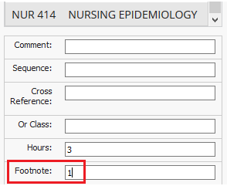

- To build your footnote table from scratch, place your curser in the spot you want it, usually directly underneath your course list

- Once your curser is in the right spot, select the table icon in the toolbar

- Select ‘Footnotes’ from the drop-down field then click ok
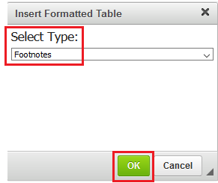

- Select ‘New Footnote’ then type the symbol or number into the Symbol field
- Write your text underneath the toolbar
  - You can add additional formatting if needed but use sparingly – bolding, underlining or italicizing is most effective on one word not whole sentences

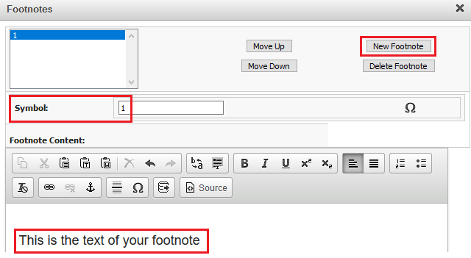
- Add multiple footnotes by selecting ‘New Footnote’ after each text entry then press ok

Build a Sample Curriculum Plan
Per Curriculum Council policy, a four year term-by-term plan of courses must submitted in proposals for all new and existing undergraduate majors. Courses should be listed per term and include all necessary Baccalaureate Core coursework needed to complete the degree. The credit total should equal 180 (or more for certain engineering programs).
- If you want to use a sample plan from an existing program as a template, contact cim.help@oregonstate.edu and they will copy one into your proposal
- Once populated, double-click on the table outlined in blue and then follow the instructions from step 2 below

- To build your sample plan from scratch, select the table icon in the toolbar

- Select ‘Plan of Study Grid’ from the drop-down field (it should appear second in the list) then click ok

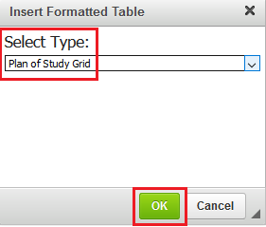

- Select the starting term (the default should always be Fall) and then select ‘First Year’ and ‘Fall’

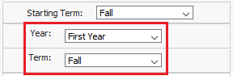

- Using the instructions in steps 3 to 10 for ‘Build a Course List’ (above), add courses and text from the left-hand side to build the sample plan on the right-hand side
  - Plans should be generic – in lieu of specific courses, use generic text such as ‘Bacc Core’ and ‘Elective’
  - Do not list groups of possible electives – these are already listed in your requirements and do not need to be repeated for a sample plan
  - If you offer multiple options under your major, create only one sample plan and use ‘Option Course’ to indicate where an option course may be taken, in lieu of listing the specific requirements for each option

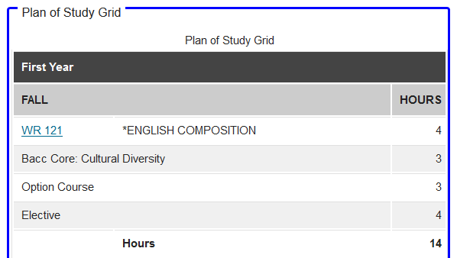

- Once each term is completed, select a new term in the drop-down fields on the right hand side

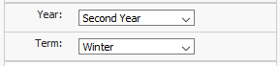

Frequently Asked Questions

Catalog Content Not Showing in CIM
The Office of the Registrar is responsible for managing certain content on program pages in the Catalog. The following information will not appear in CIM and you do not need to add it to your proposal but it will appear in the Catalog:
- Graduate areas of concentration (approved by the Graduate School)
- Links to options and majors
- Campus availability
- SIS code
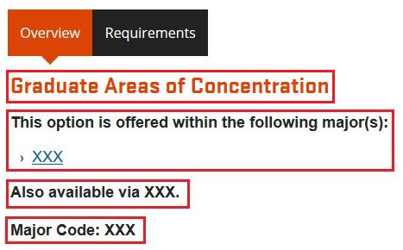

You also won't find contact details for specific programs in CIM because they do not need to be approved through the curriculum process. If you want to add or edit the contact details listed for your program, email catalog@oregonstate.edu

Standardized Language and Formatting
For consistency across the university and to assist students with disabilities who read the Catalog through a Screen Reader, we enforce standardized language and formatting in program requirements. Sometimes a proposal will be sent back to the originator for adjustment but more often tweaks to language and formatting are made by the Office of the Registrar prior to publication. If you have concerns about changes made to a specific Catalog entry, email catalog@oregonstate.edu

The following examples show common language and formatting changes made to program requirements:
- Select one course from the following:
  - Instead of ‘Take one of the following:’ or ‘Choose one from below:’
- Visit the school's website
  - Instead of ‘Visit the school's website at http://health.oregonstate.edu/bphs’
- AEC/ECON 352
  - Instead of ‘AEC 352 or ECON 352’

Total Hours are Incorrect
Minimum credit hours for majors, minors, options and certificates are governed by the Minimum Credit Hour Policy. Your proposal will be rejected if the total hours in your course list does not meet the minimum requirement for the program or you do not otherwise adequately/clearly demonstrate how the credits are achieved. In some cases, using the ‘sum’ feature in the course list will give a value that is not representative of the credits required for your program. There are a number of reasons for this:

- Additional electives may be getting added to the total – to fix, go back into the course list and indent all relevant electives
- A course may have changed or be in the process of changing credits – to fix, manually enter the credits as they will be for the next catalog. Eg, if PSY 201 is currently 3 credits but a proposal changing it to 4 credits is in progress and will be effective in the next academic year, type 4 into the credit field
- Blanket, special topics or repeatable courses may not show your desired credits – repeatable courses will default to their fixed credit value and variable courses will default to their credit range. To fix, go back into the course list and manually type over the credit value. Eg, if you allow up to 6 credits to count from a blanket course with variable credits 1-16, type 6 into the credit field
- A credit range applies to multiple sections of your requirements – to fix, go back into the course list and add two colons (::) and a fixed credit after the credit range. The fixed credit will be what gets added to the total. Eg, if you have two focus areas with a credit range 12-16, 12 will be the minimum value that gets added to your total for each. Add ::14 after each range so that 28 gets added to the total, not 24

