Curriculum Inventory Management [CIM]
Quick Start Guide for Courses

TO PROPOSE A CHANGE TO AN EXISTING COURSE:

- Go to https://nextcatalog.oregonstate.edu/courseadmin/

- Log on using your ONID username and your standard password. DUO is required.

- In the field to the left of the Search button, enter the subject code and number (e.g., WR 121 with a space in between) of the course proposal you wish to edit and press the green Search button. If the course already exists, it will be displayed below the course listing box.
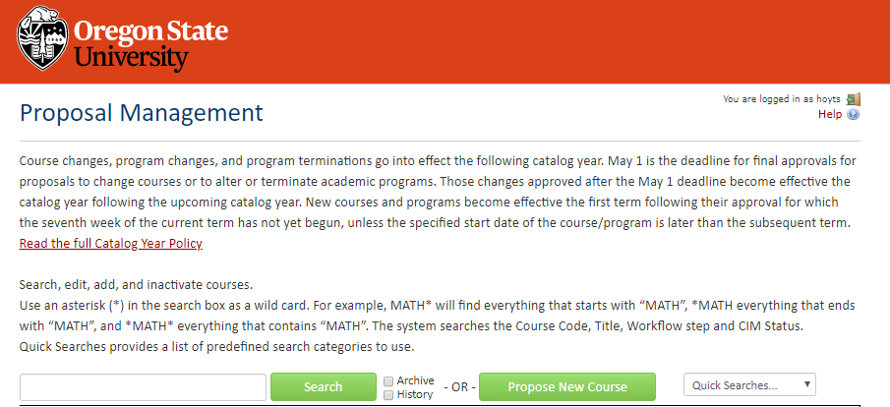

- If there is a list of courses, click on the course you want to edit. If there is just one course, it already will be selected.

- Review the field (Course Ecosystem) immediately below the course title. This area lists where the course appears in the academic catalog and shows the courses and programs that will be impacted by changes to this course. Review this list before selecting liaisons for the proposal.
Course Ecosystem

- Click on the green Edit Course button to open the form.

Complete all required fields (outlined in red) before submitting your proposal. CIM forms are dynamic, so fields open and close based on selections you make early in the form. To save you time and effort, it is essential that you complete the following fields at the start of every course edit proposal:
- Type of Course
- Type of Change
- Subject Code
- Course Number

- To upload your syllabus, click the green Attach File button at the bottom of the form. A Browse file box will open and you can select the file(s) to upload. Upload your syllabus as a Word document.

- To save the information you have entered, without submitting the proposal, scroll to the bottom of the form and press the Save Changes button. You can do this as often as you like.

- Once your proposal is complete, press the green Submit button to enter it into workflow (start the review process).

Tips:
- Hover or click on help bubbles on the form for more information.
- Required fields are outlined in red.

Questions? Contact cim.help@oregonstate.edu

