- Go to https://nextcatalog.oregonstate.edu/courseadmin/

- Log on using your ONID username and standard password. DUO is required. If you are not able to login to CIM, contact cim.help@oregonstate.edu and an administrator will grant you access.

- In the field to the left of the Search button, enter the subject code and number of the course you wish to edit and press the green Search button. If the course already exists, it will be displayed below the course listing box and already be selected.
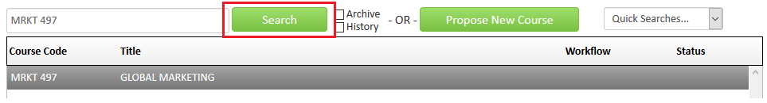

- Click on the green Edit Course button to open the form.

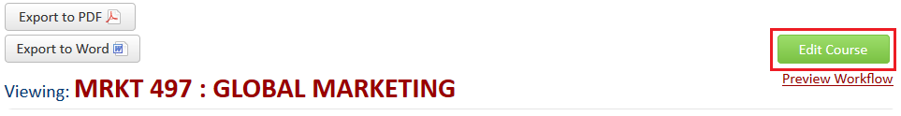

- CIM forms are dynamic so fields open and close based on selections you make early in the form. To ensure your request is expedited, it is essential that you select ‘Change Schedule Type, Crosslisting or Campus’ as the type of change. The form will shrink and only show fields that you are eligible to change.

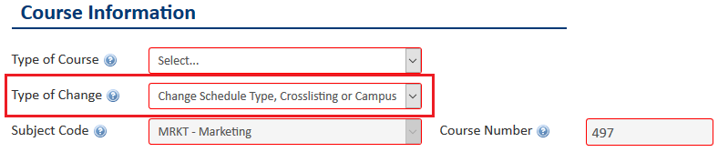

- You must complete all required fields (outlined in red) before you can submit the proposal. Some fields will pre-populate but as CIM is a new system, you will need to make additional selections. The form will remember those selections once the proposal has been approved the first time. Refer to the blue help bubbles if you are unsure what each field is referring to.

Effective Term: Select the term when you would like the change to apply – this can be different to the term in which you want to teach the course in that format. Eg, For a crosslist request, if the effective term is Summer 2020, the course will appear in the Catalog as crosslisted from Summer 2020 even though you may not schedule the class until Spring 2021.

Justification: In a short sentence, explain what you are requesting. Eg, ‘Adding XX schedule type.’

Primary Originators: Select yourself from the drop-down list. You may add other people if you wish but only the primary originator (the person who ‘submits’ the proposal) will receive notification of approval.

Liaisons: Select ‘::Liaison not required’ unless liaisons have pre-populated. Do not remove liaisons if they have pre-populated – your proposal will not be sent to them for this request but they remain in the form for future proposals.
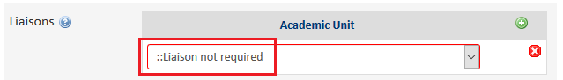

Type of Course: Most courses are ‘regular’ – do not select another course type unless you are sure what it is. Blanket, experimental and special topics courses have unique numbering.

Honors: Do not edit this field – honors courses cannot be added through this process.

Crosslist: Most crosslisted courses have the same number but different subject code. Once the crosslist is established, the courses are linked through CIM and cannot be edited separately. All components must be the same – level, title, credits, description. Use the red Add link next the crosslist label and then enter the details into the course code widget.

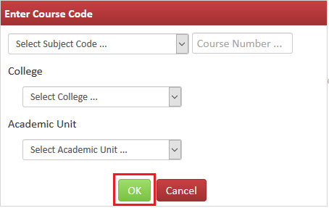

Once you have pressed ok, you have the option to add another crosslist course, edit or remove the course you just entered or make it the primary course. As crosslisted courses are linked together in CIM, one must always be the parent even though in Banner, they will have the same status.

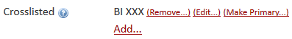

Slashlist: Do not edit this field – slash courses cannot be added through this process.

Schedule Type: Schedule types already in Banner at course level will pre-populate to the form. If you wish to add a new schedule type, check the relevant box. Laboratory and recitation are exceptions and cannot be added through this process. Requests to add laboratory or recitation require a full proposal, as does studio in certain situations. Contact cim.help@oregonstate.edu if you have questions.

Campus Locations: Make your best attempt to select all locations where this course is (or will be) offered.

Anticipated Scheduling: Make your best attempt to select all the terms where this course is (or will be) taught for all campuses – you can change scheduling later if you wish and do not need to submit another proposal to do so.

- To save the information you have entered, without submitting the proposal, scroll to the bottom of the form and press the Save Changes button. You can do this as often as you like.
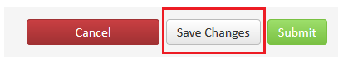

- Once your proposal is complete, press the green Submit button to enter it into workflow (start the review process).
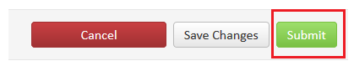

- You can see the review steps of your proposal once you submit it into workflow. You will receive an email notification once your request is approved.

