How to Run “Report Browser” Reports for Individual Courses and Instructors.

These reports provide the 2020 qualitative evaluation information by instructor and/or courses that can be combined.

Pull up Report Browser

Log in to eSET: https://xe.ucsadm.oregonstate.edu:9990/ords/prod/twbkwbis.P_WWWLogin?ret_code=E

Open “Menu” in the upper right corner.

Choose “Reports”.

Select “Report Browser”.

(for more information on these steps, including images, please see “Welcome to eSET”.)

Report Browser Screen
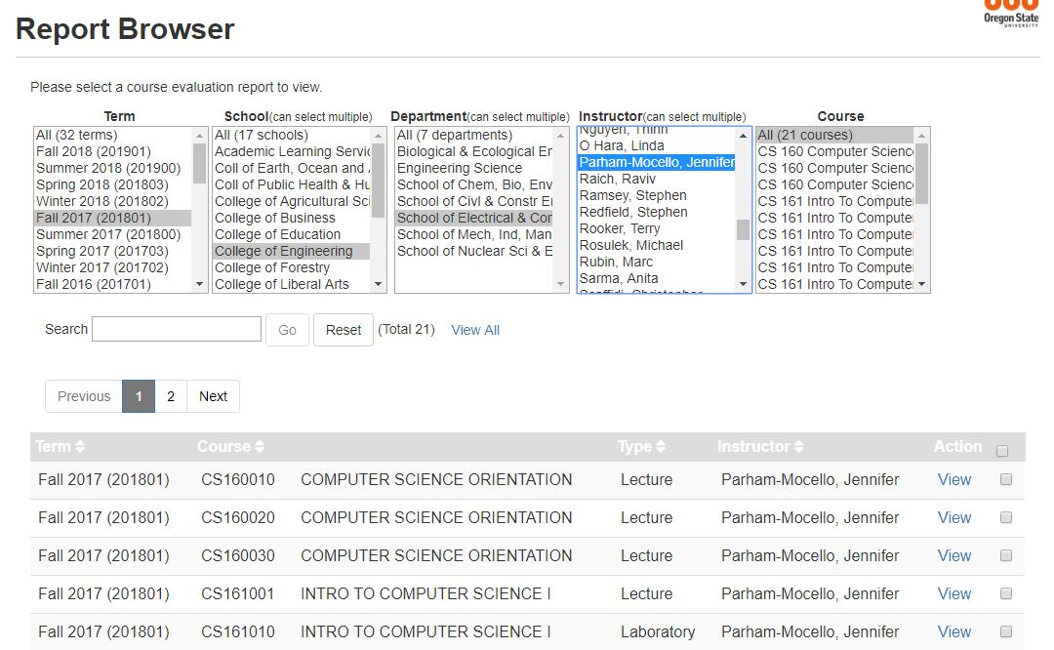

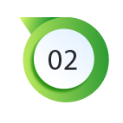

Select data
- Narrow visible courses to find desired data.
  - Select any of the following to narrow your visible courses:
        - Term (single term or all since 2011)
        - College (called school on eSET forms)
        - School/Department (called department on eSET forms)
        - Faculty member (called instructor on eSET forms)
  - Multiple Colleges, Departments and Instructors can be selected by holding down the control key.
  - Please be aware that selecting data for all terms can cause the program to run slowly. Additionally, older term evaluations may have used different College or Departmental titles.
- Enable the ability to see all courses indicated by selecting “View All” link located roughly in the middle of the screen.
  - Pop-up window may appear. Click “Yes”.
  - This action is often slow; you will know it is complete when the “view all” link is gone.
- Select courses desired by clicking the box to the right of each course. Use the “Action” box on far right side to select all.
- Scroll to bottom of the list. Create batch file by clicking “Create Batch File>>”.
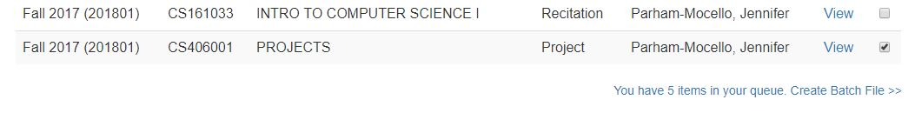

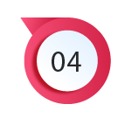

Create file for export
- Scroll to top of new screen view.
- Look over course selection for accuracy.
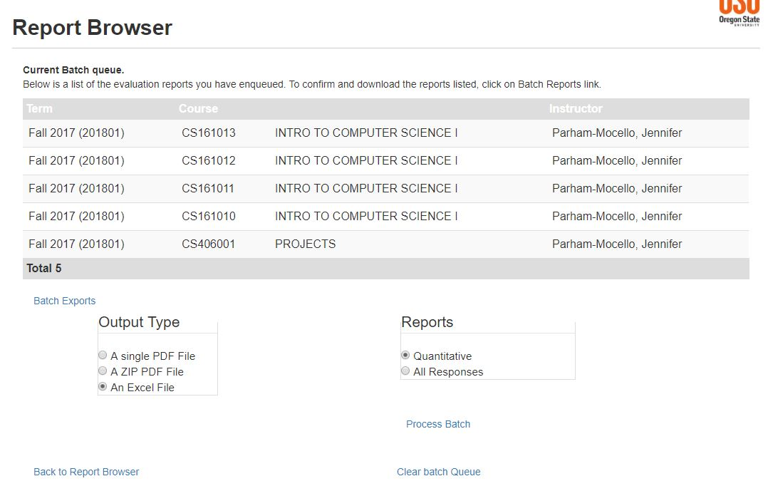

- Create file for export by clicking on link on lower left called “Batch Exports”.
- Select file format
For Spring 2020, we recommend using either a single or multiple (ZIP) PDF files and the “Comments 2020” Report. This will give all signed comments by course. Instructors will need to access anonymous comments individually through their eSET portal.
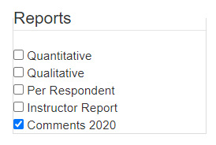

- Prepare file by clicking “Process Batch”.
- Download file when complete (may have to scroll to top of screen to find button; PDF files may take extra time).
- To print another report, select “Clear batch Queue”.

