NON-CREDIT COURSE

- Overview

- Non-credit course is also known as zero-credit course. It allows students the opportunity to engage in non-credit academic experiences that are transcript visible. The students will be graded based on the criteria of SC (Successful Completion) and NSC (Non-Successful Completion).

- The review process of a non-credit course involves several parties:
- Curriculum Management and Office of the Registrar.
These two offices will perform an administrative check of the proposal
- College committee Approver
- Lastly, the Curriculum Council

- Course Number and Name
- Each non-credit course has a unique course number that is specific to the academic experience as listed in the OtR website. The course title for each NC course must be specific to the experience, as shown in the table below.
Course Number | Academic Experience
001 | Service Learning
002 | Leadership
003 | Undergraduate Research
004 | Internship
005 | Capstone
006 | Education Abroad

- Just like in blanket and special topics courses, the non-credit course could have different sections with different content.
- Example: For Leadership, use 002 as the course number and the course name would be Leadership. Do not add any specifics to the course name such as Leadership in K-12 Schools. You can add a more specific title at the section level when scheduling.

- Course Description
The course description of a non-credit course is standardized and specific to the non-credit experience. Copy and paste the standard course description from the OtR website into the course description field.

- Student Learning Outcomes
The OtR website website also list the student learning outcomes.
The Learning Outcomes do not have to be identical to the ones listed in the website, but they should be along a similar vein. The Learning Outcomes for each non-credit experience were carefully selected by the Non-Credit Course Task Force. Students are not getting credit so there is a slight flexibility in here. But, since the non-credit courses are transcript-visible, it's important that the LOs are not too out-of-scope but maintain academic rigor. You can select 5-7 Learning Outcomes that you deem most appropriate.

- Students Assessment
The OtR website website lists some suggestions for the student’s assessment. Select the ones that you deem most appropriate
- Syllabus
- Do ensure that the syllabus meets the Syllabus Minimum Requirement. You can find the information on the Syllabus Minimum requirement at the this website.
- Another thing that you want to make sure is for the syllabus content to match the information in the proposal.

Steps to submit a non-credit course proposal in CIM
- Go to https://nextcatalog.oregonstate.edu/courseadmin/
- Click the green Propose New Course button.
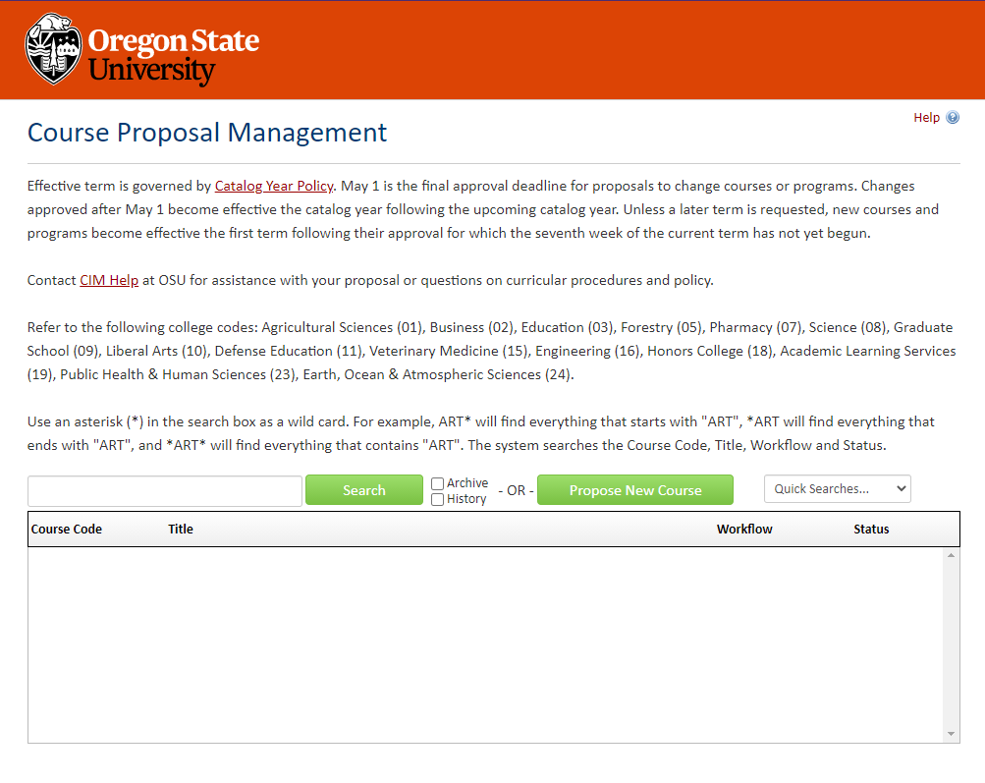
- You will see a pop-up window (CIM form) opens.
CIM forms are dynamic, so fields open and close based on selections you make early in the form. To save you time and effort, it is essential that you choose “Non-Credit (0 level)” under the Type of Course.

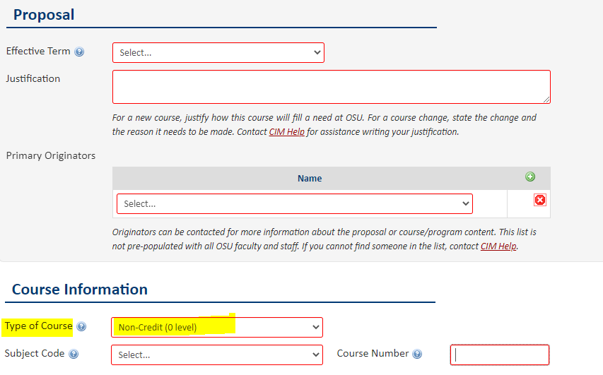

- Complete all required fields (outlined in red) before submitting your proposal.

- Lastly, attach the course syllabus by clicking the Attach File button.

- To save your draft work, click Save Changes. Once your proposal is complete, press the green Submit button to enter it into workflow (start the review process).
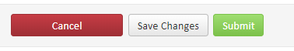

Questions? Contact cim.help@oregonstate.edu

